INTERNSHIP TASK REPORT

Build Your Personal Cybersecurity Lab – Task 2
Intern Name: Diksha Pandit Jadhav
Intern ID: MT2491
Course: Diploma in Computer Science Engineering (3rd Year)
Institute: Sanjeevan Engineering and Technology Institute, Panhala
Internship Organization: Maincrafts Technology
Domain: Cyber Security & Ethical Hacking
Internship Duration: 14 February 2026 – 14 May 2026

Objective

To build a safe and isolated cybersecurity practice environment using virtualization and penetration testing tools such as Kali Linux and Burp Suite.

Tools Used

- Oracle VirtualBox
- Kali Linux
- Burp Suite Community Edition
- Web Browser

Procedure with Screenshots

Step 1:

Install VirtualBox
Oracle VirtualBox was installed to run virtual machines on the host system.

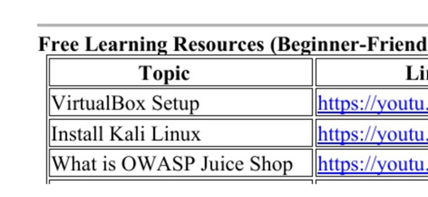

Step 2:

Download Kali Linux
The Kali Linux virtual machine image was downloaded from the official Kali Linux website.

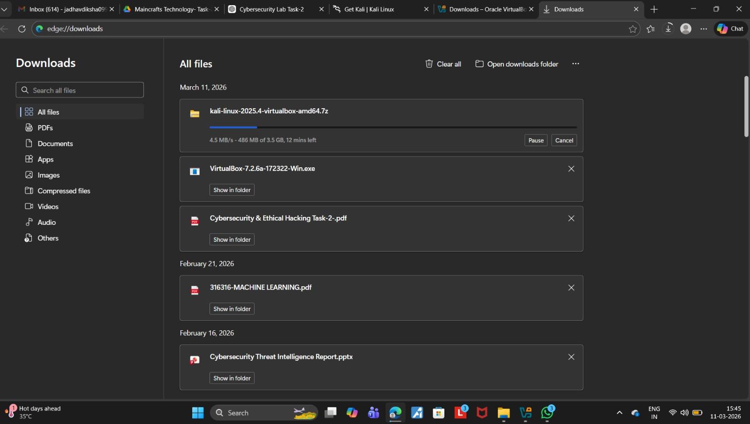
Download Started
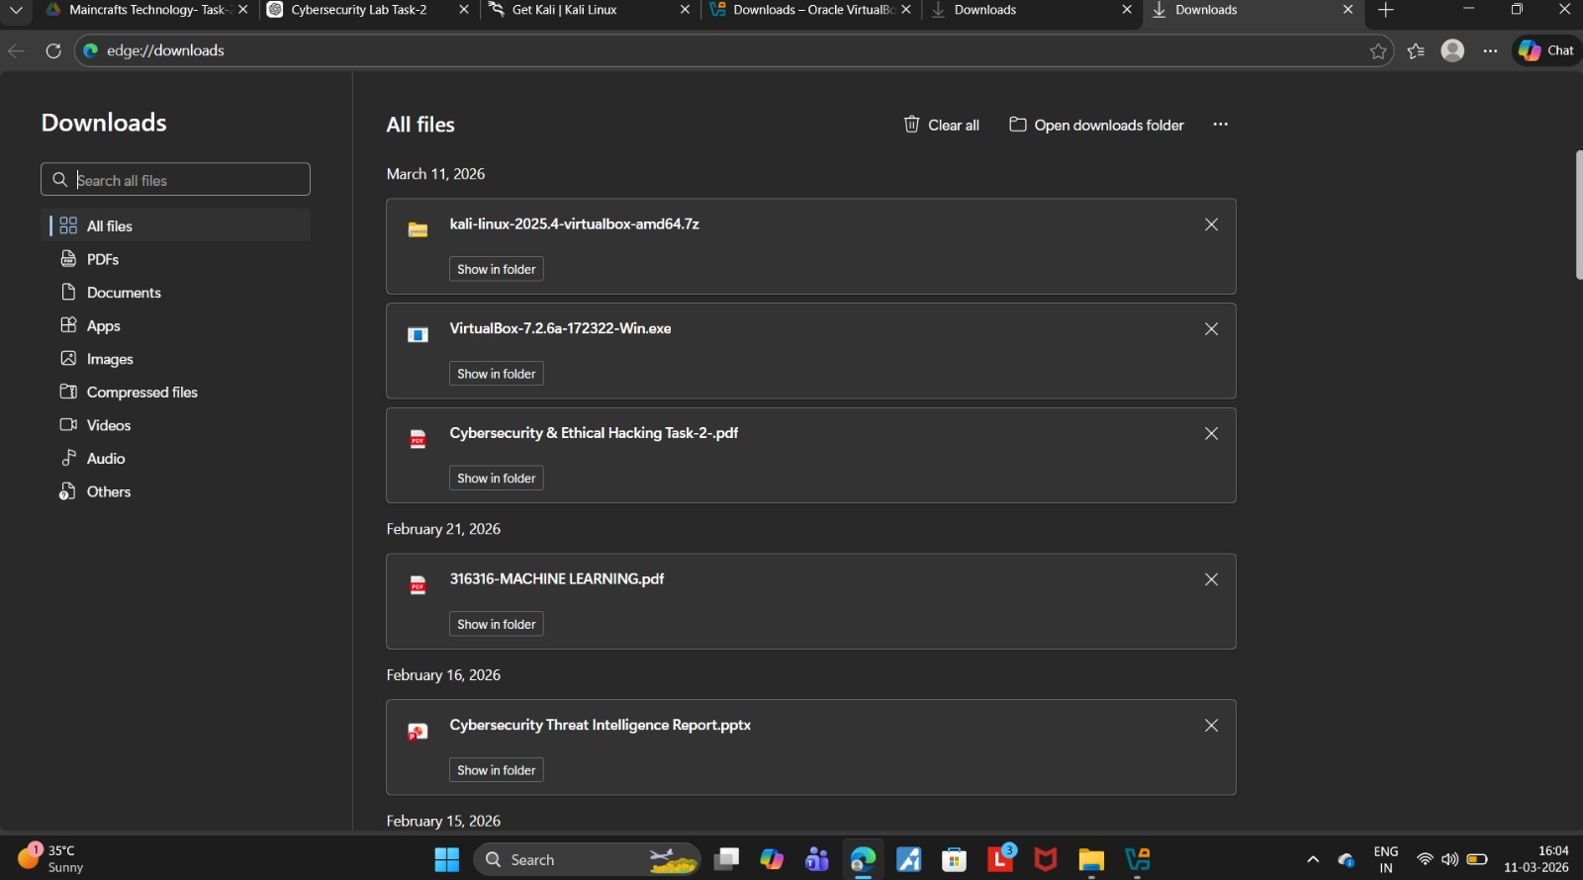
After the download completed, the file was extracted successfully.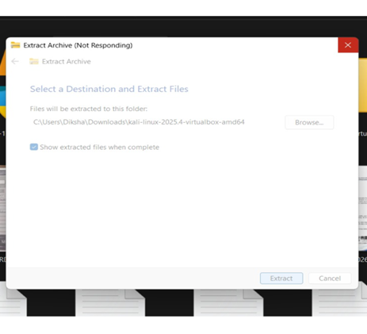

Step 3:

Start Kali Linux
Click on open select downloaded folder

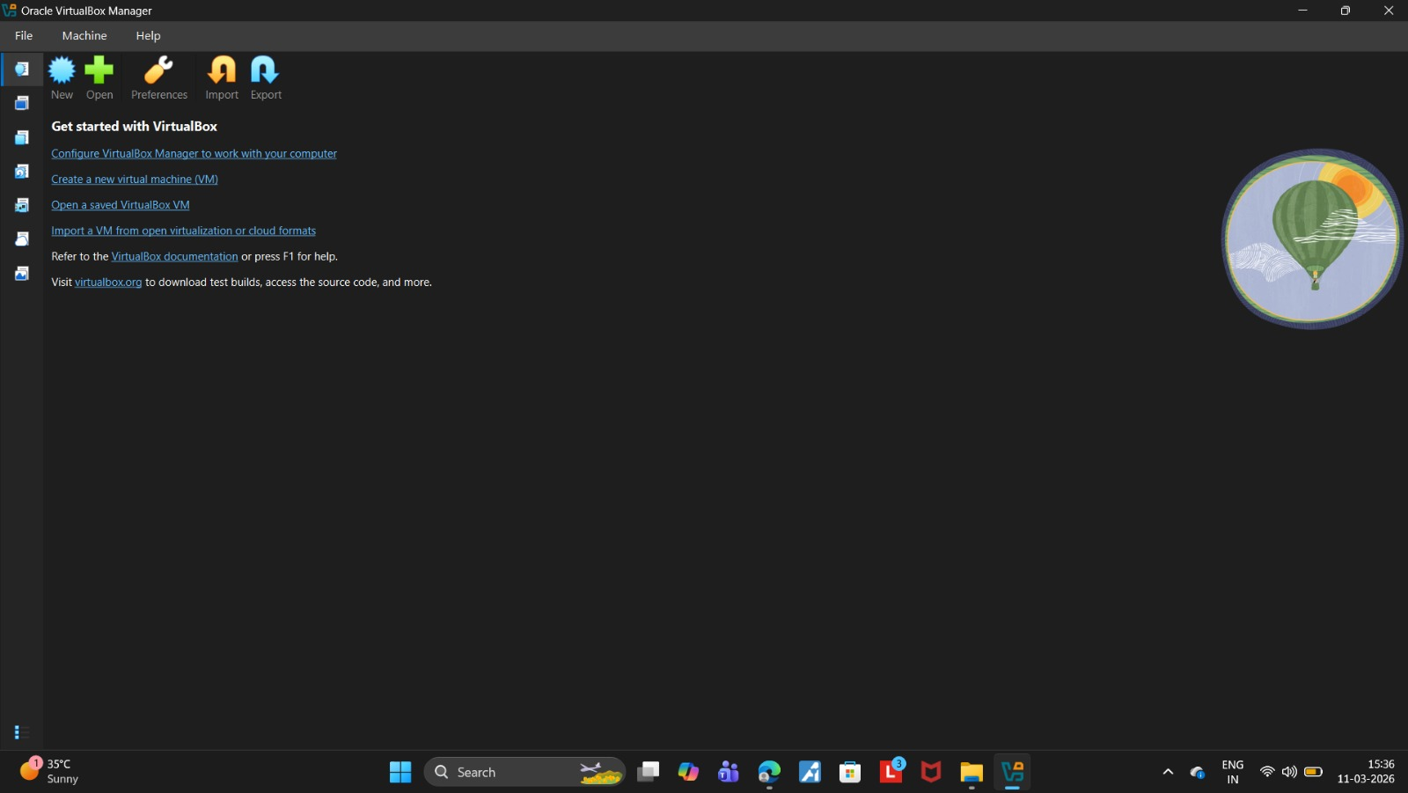
The virtual machine was started and Kali Linux was successfully launched.

Step 4:

Start Kali Linux
The virtual machine was started and Kali Linux was successfully launched.
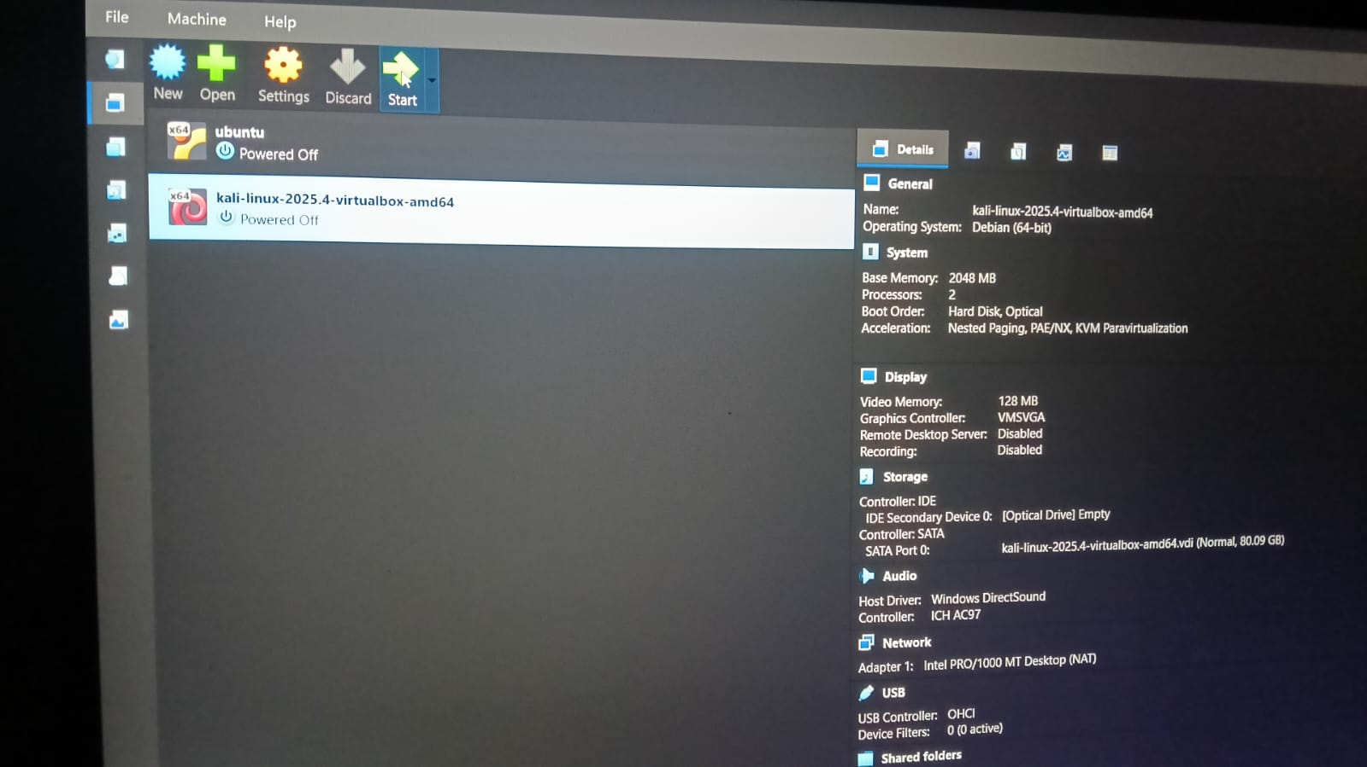

Step 5:
Update System
System packages were updated using the terminal command:
sudo apt update
sudo apt upgrade

Step 6:
Install Security Tools
Burp Suite and Wireshark were installed using the command:
sudo apt install burpsuite wireshark

Step 7:
Launch Burp Suite
Burp Suite was started using:
Burpsuite

Step 8:
Accept License Agreement
The Burp Suite Terms and Conditions were accepted.

Step 9:
Create Temporary Project
The option Temporary Project in Memory was selected.

Step 10:
Start Burp Suite
Burp Suite was started using default configuration settings.
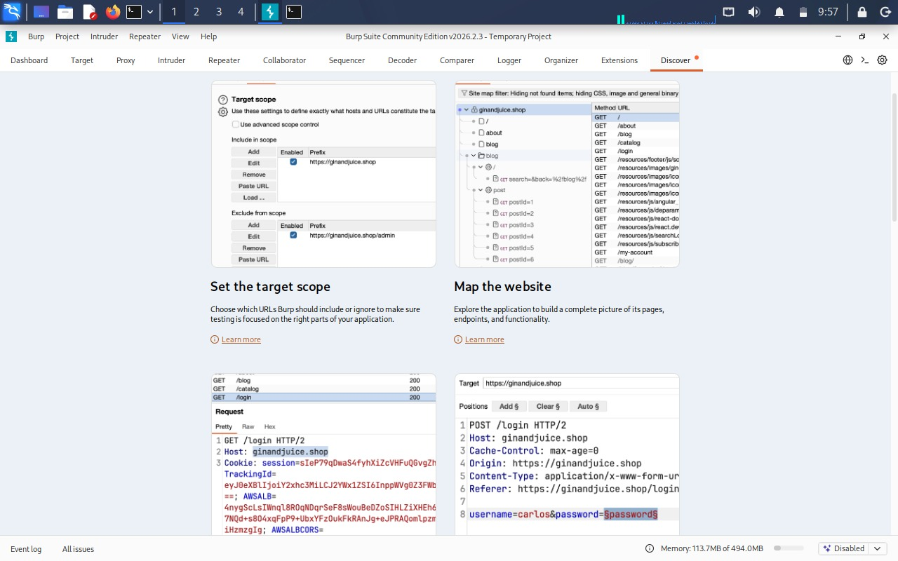

Step 11:
Open Burp Built-in Browser
The Burp Suite browser was opened from the Proxy tab.
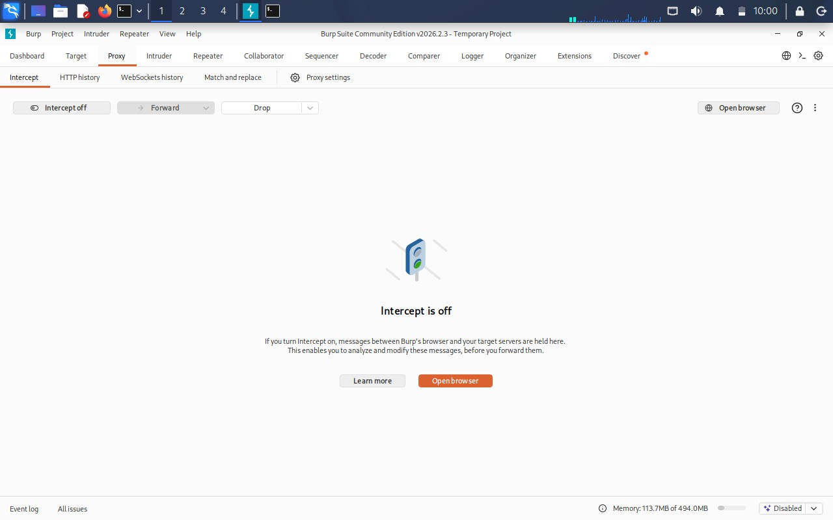

Step 12:
Visit Test Website
A test website was accessed:
http://example.com
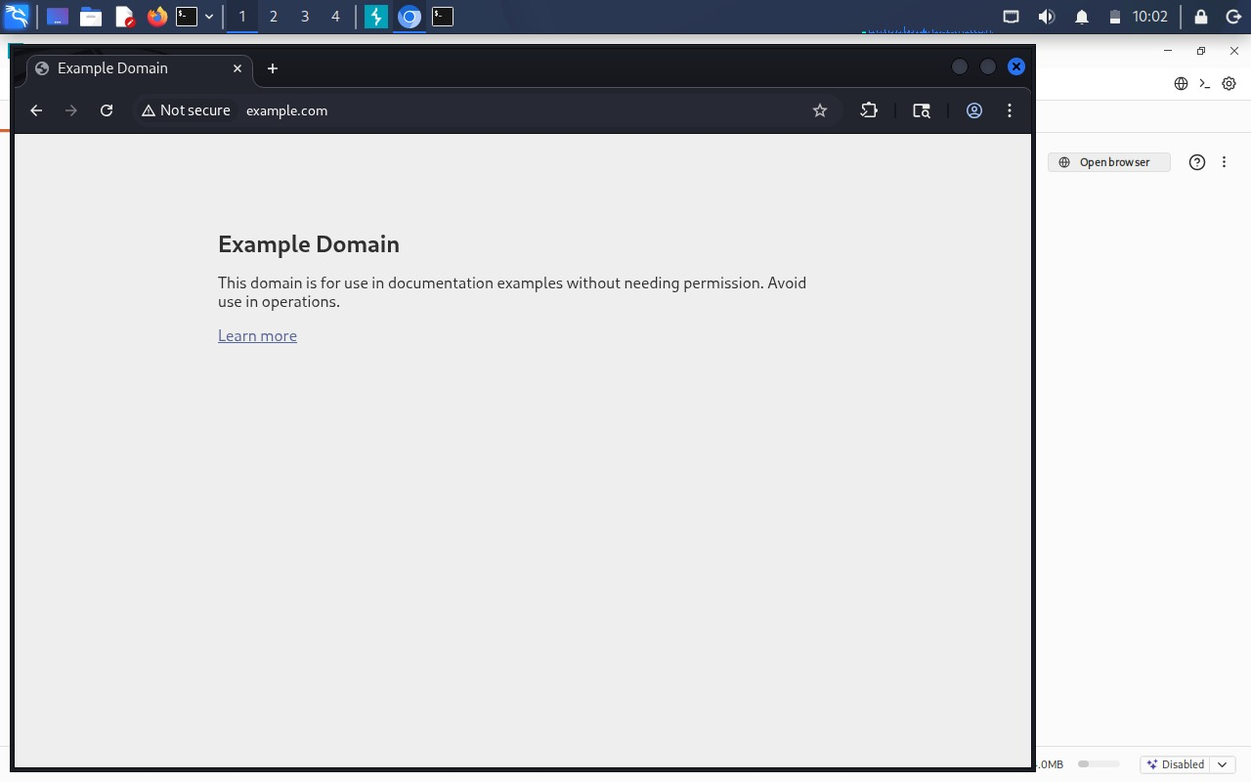

Step 13:
Capture HTTP Requests
The HTTP requests were captured in:
Proxy → HTTP History

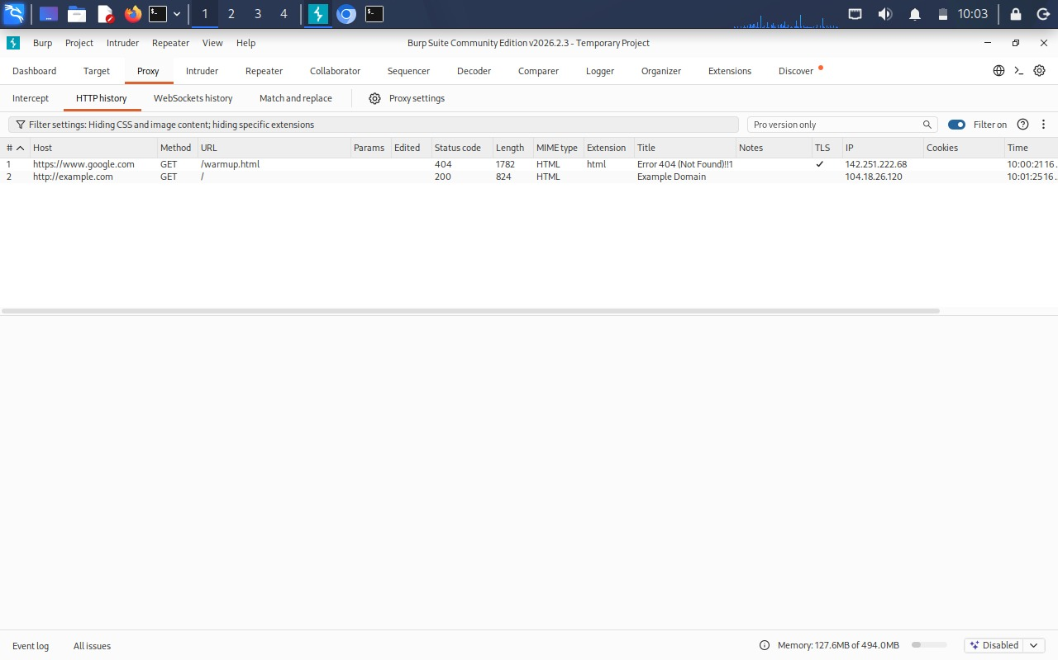

Result
Kali Linux was successfully deployed in Oracle VirtualBox and Burp Suite was used to intercept and analyze HTTP requests generated by the web browser.

Conclusion
This experiment demonstrates how a personal cybersecurity lab environment can be built using virtualization tools. The setup allows safe testing of penetration testing tools and web security analysis.

